Elastic Container Service

- Setup a highly available ecs cluster with load balancer and dynamic port mapping.
NOTE:
Your cluster should maintain atleast 6 tasks at any point of time and should be highly availble across multiple AZ's.
Use the below image from deployment:
sabair0509/hiring-app:works
Lets create a cluster
Give the cluster a name
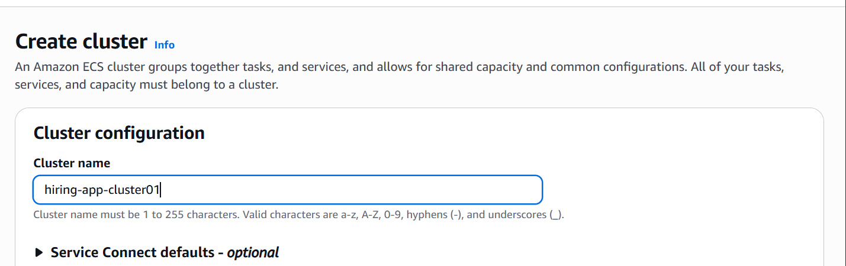
Select the infrastructure
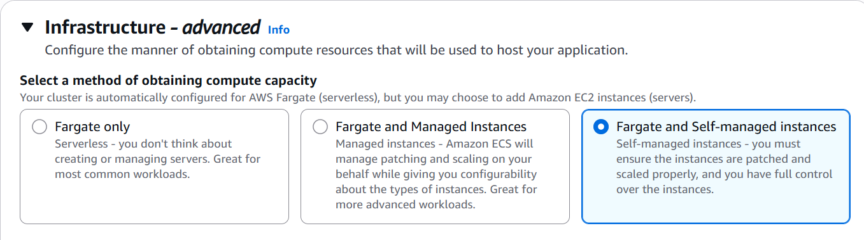
Select the instance type

Give the minimum and maximum desired capacity
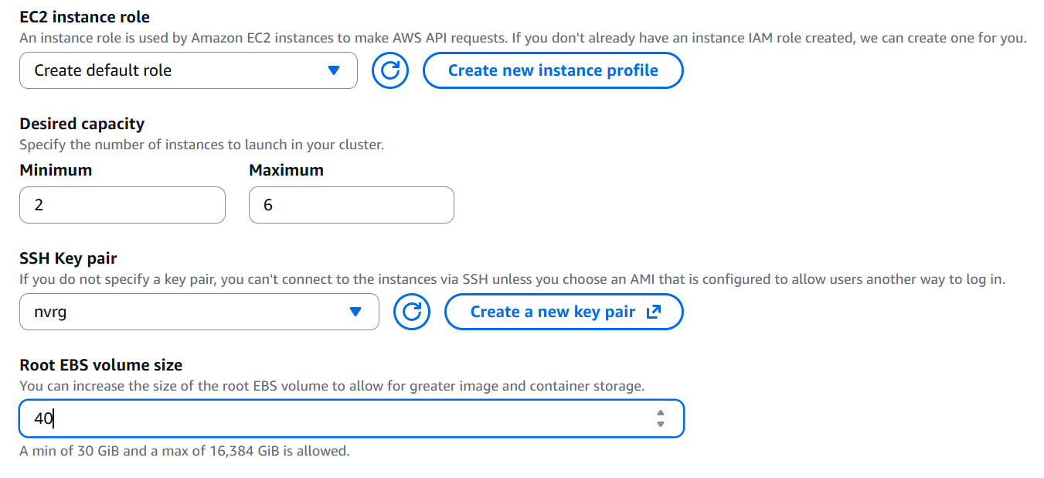
Select the vpc and subnet
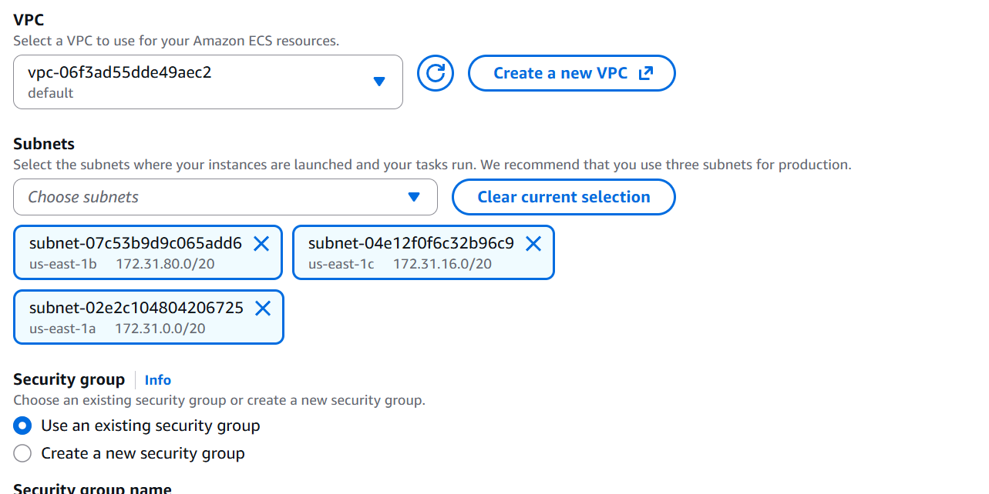

Create a new security group for ecs instance and open port 22
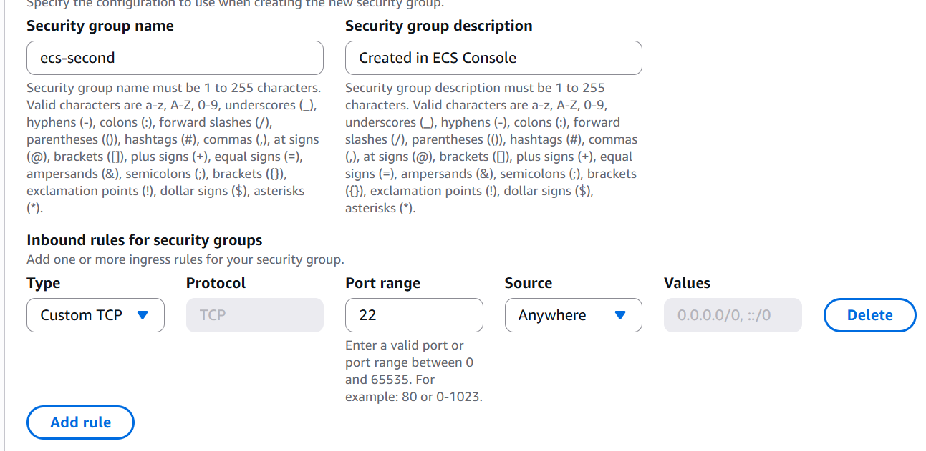

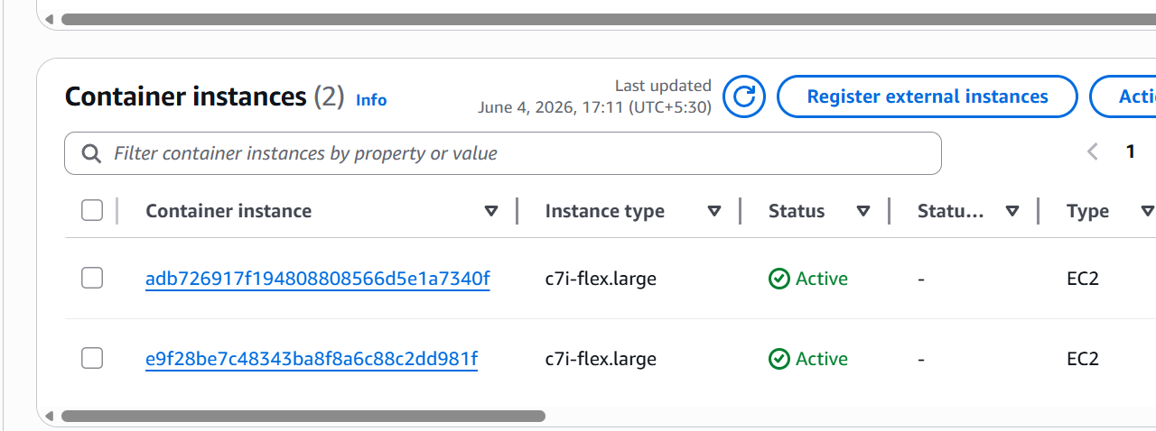

We can see that two instances are created
Now lets create a ALB
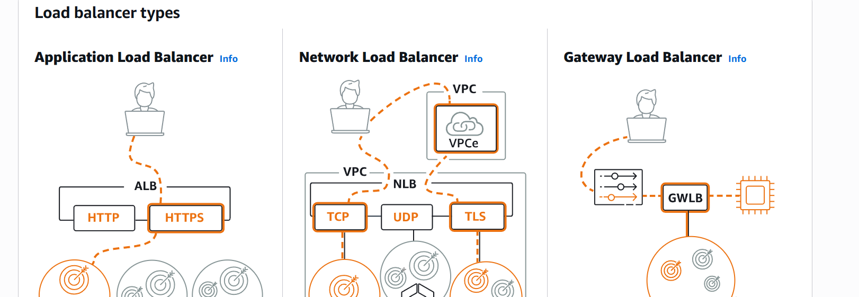
Click on ALB
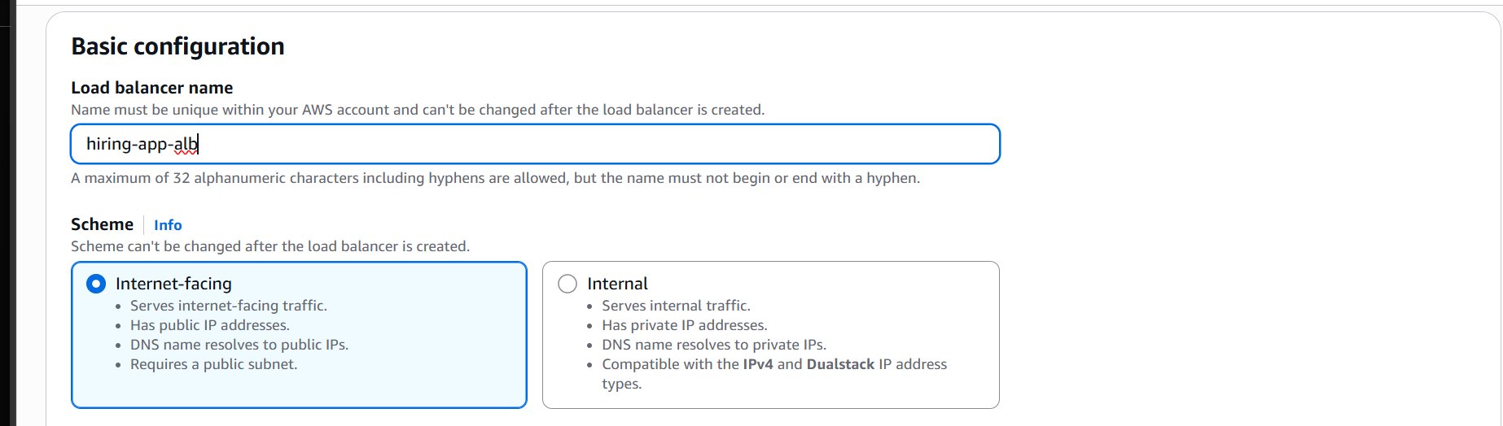
Give a name
Select the vpc same
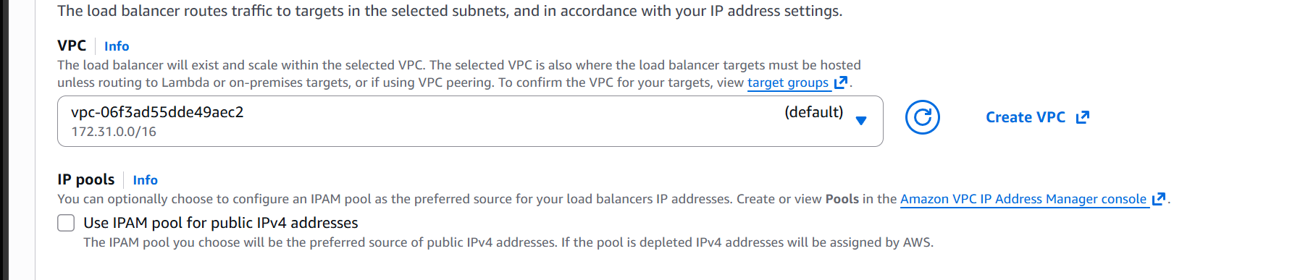
It must me same as ecs vpc
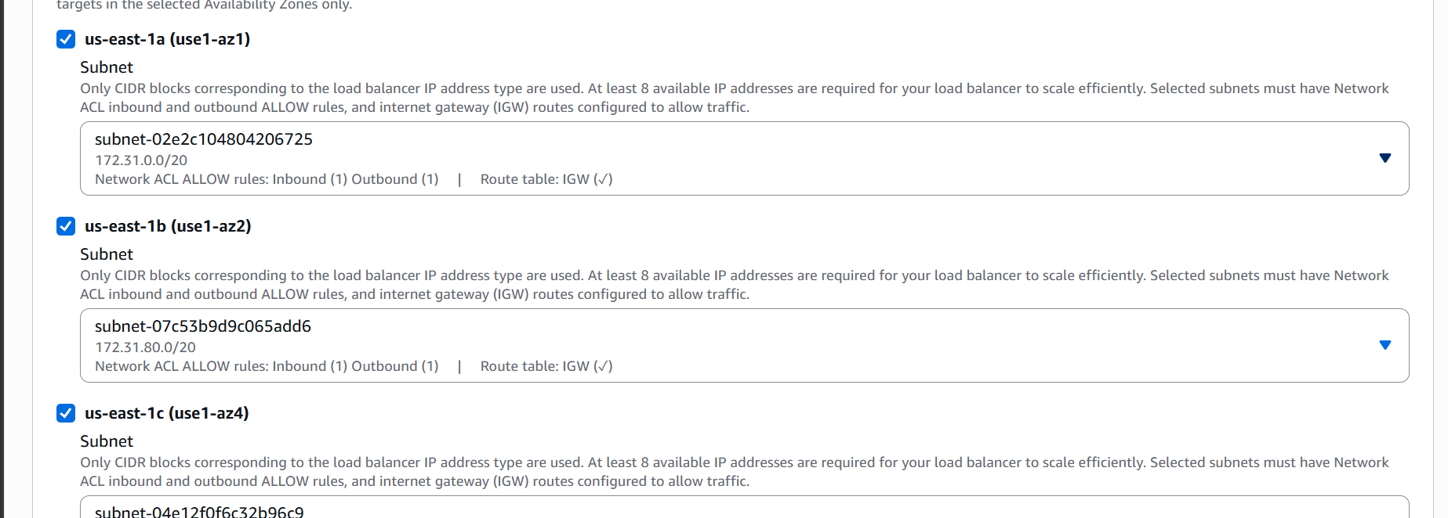
Select subnets
Now create a security group and add inbound access from 80
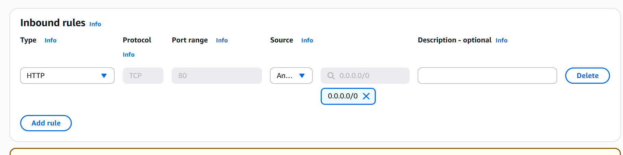
Now create security group
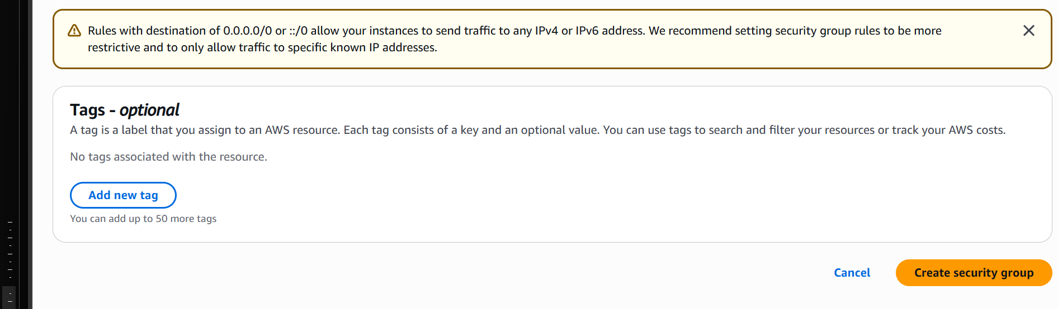

Select the security group now
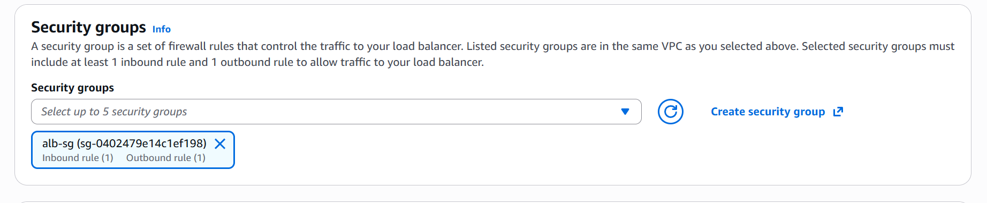

Now lets create a target group
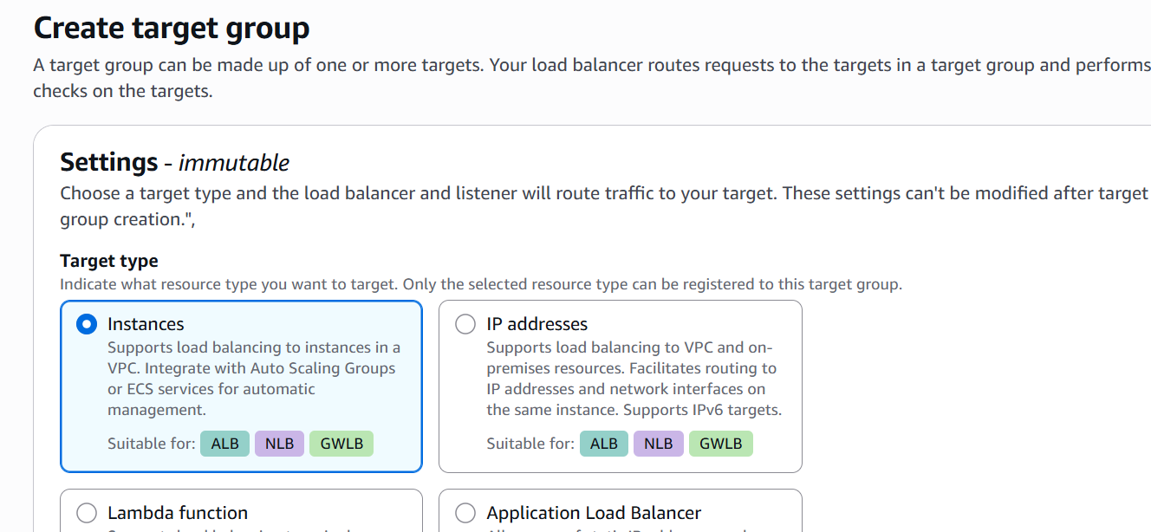

Select instances
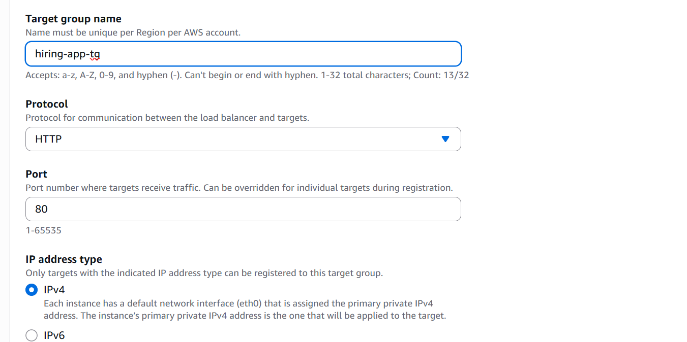
Give it a name
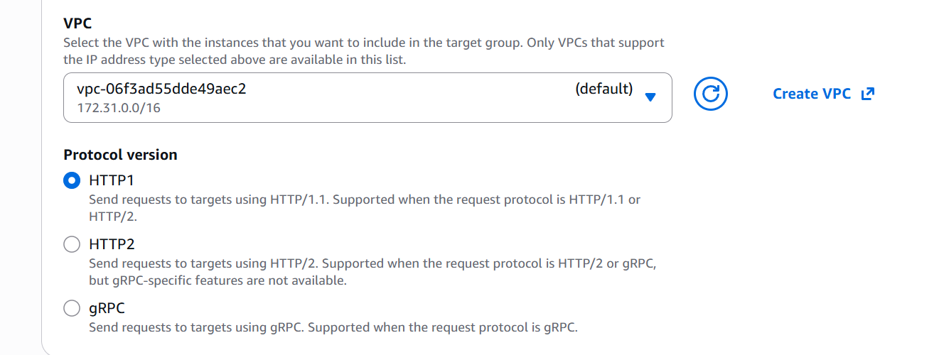
Select vpc
Now lets create the target group
Target group is now created
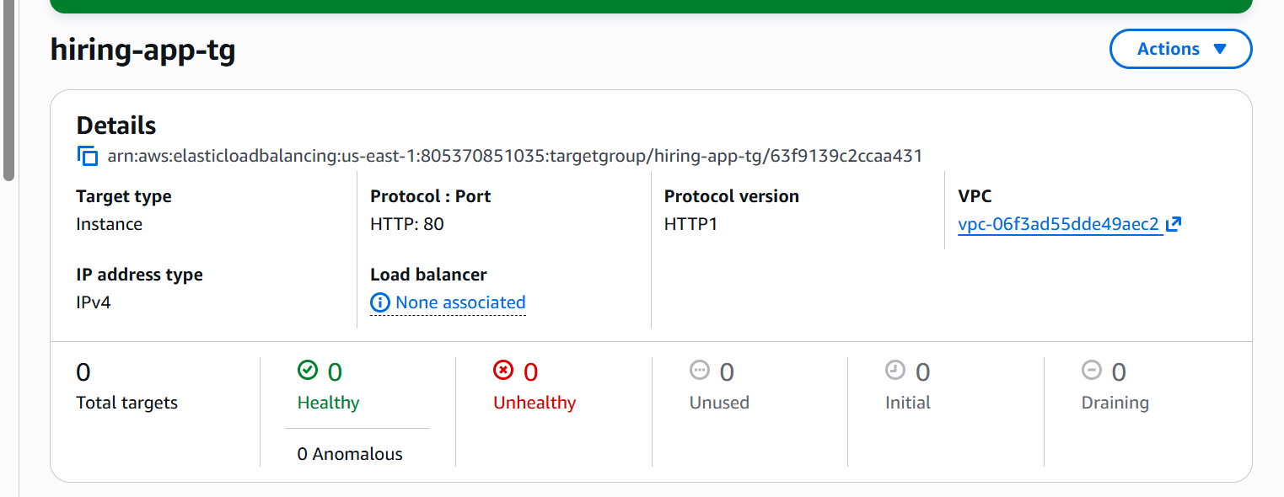
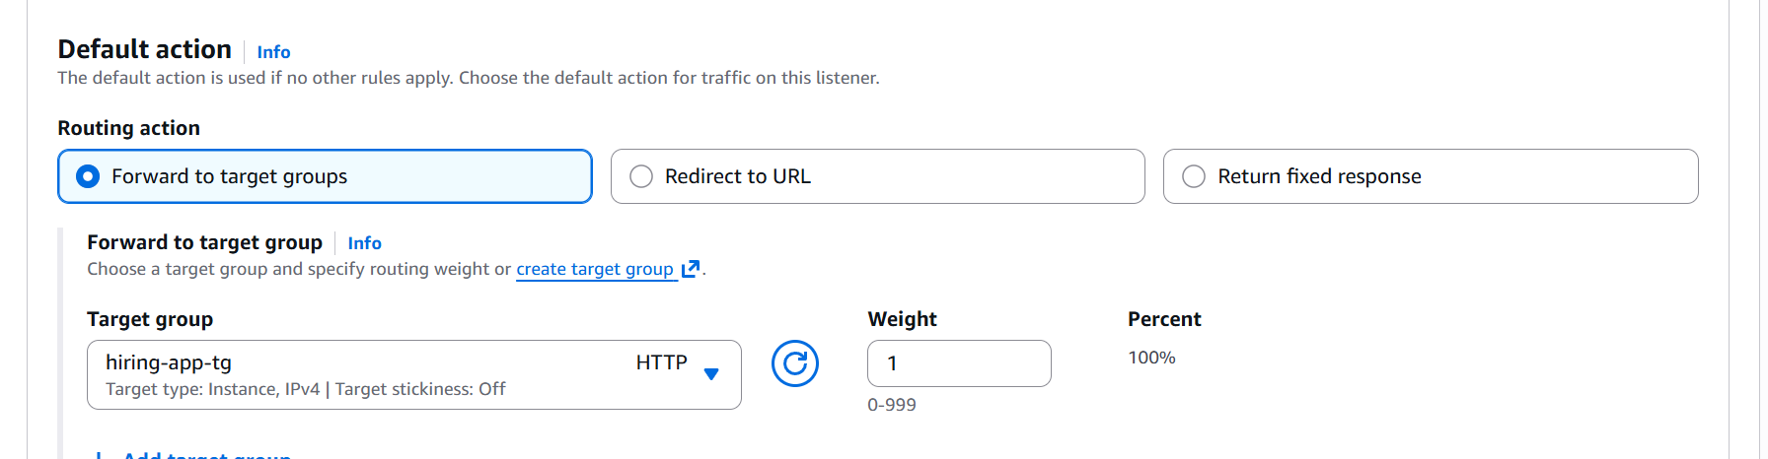

Click on create load balancer
The load balancer is now created
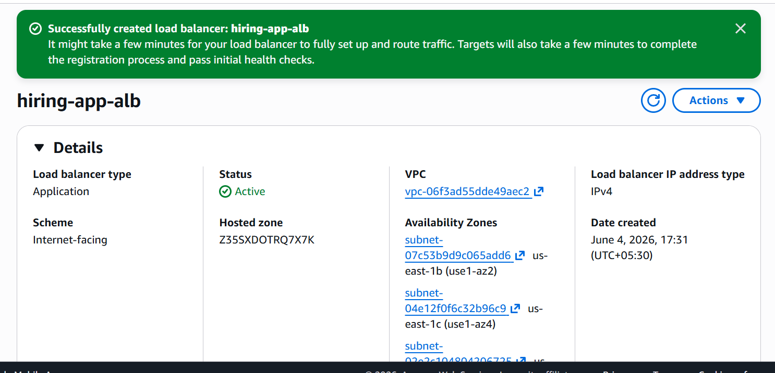

Now lets create ECS task definition
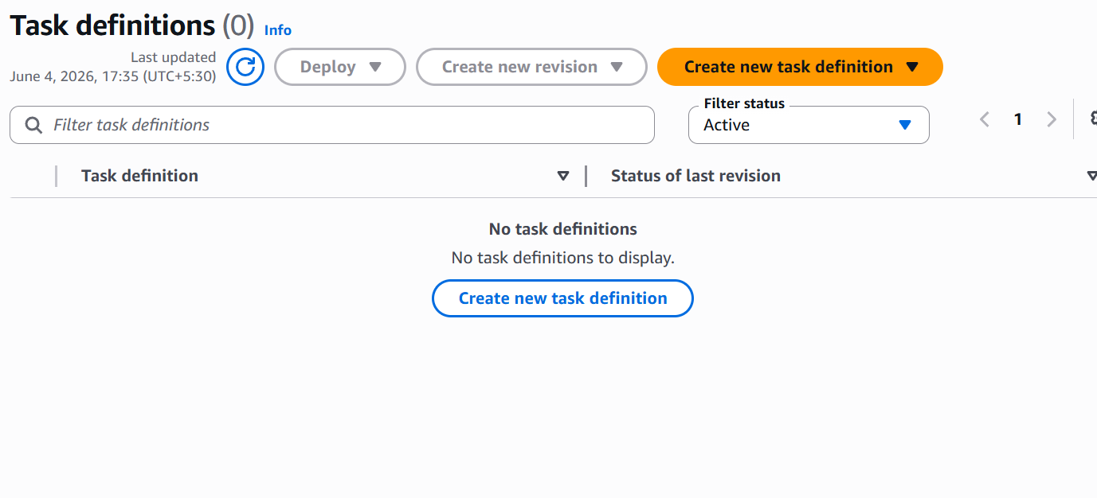
Click on create new
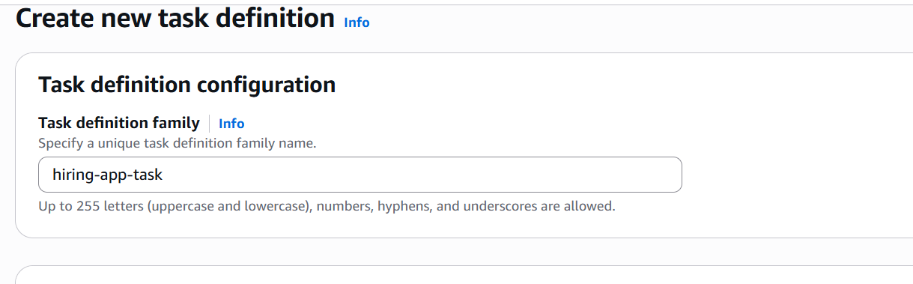
Give it a name
In Infra requirements select EC2
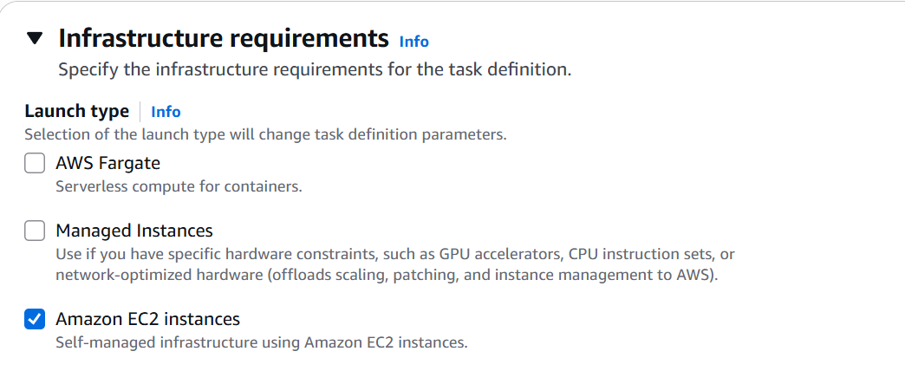
Select network mode as bridge
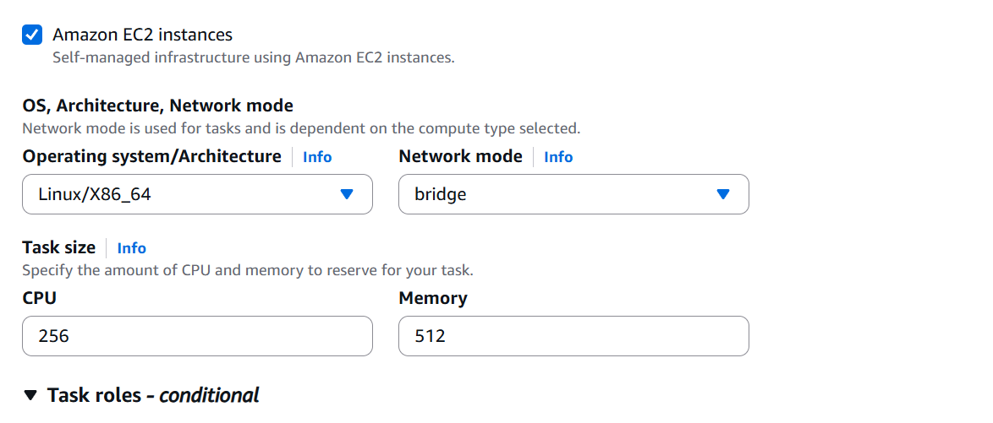
Give the container details now

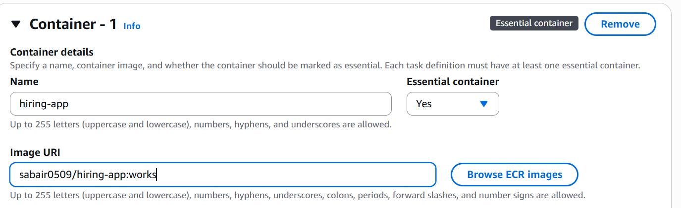

Create the task definition now
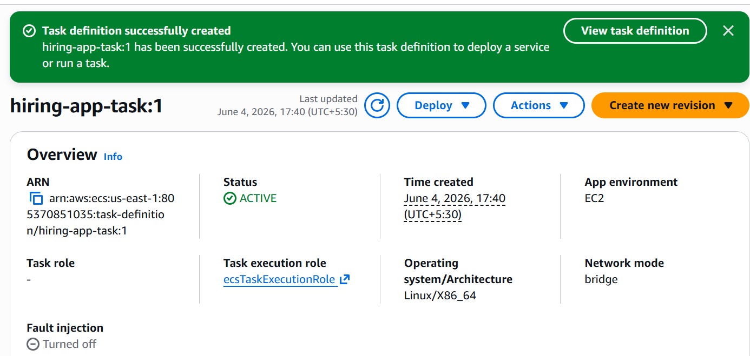
Task definition is created
Lets now create a ECS service
Go to the cluster and click on create service
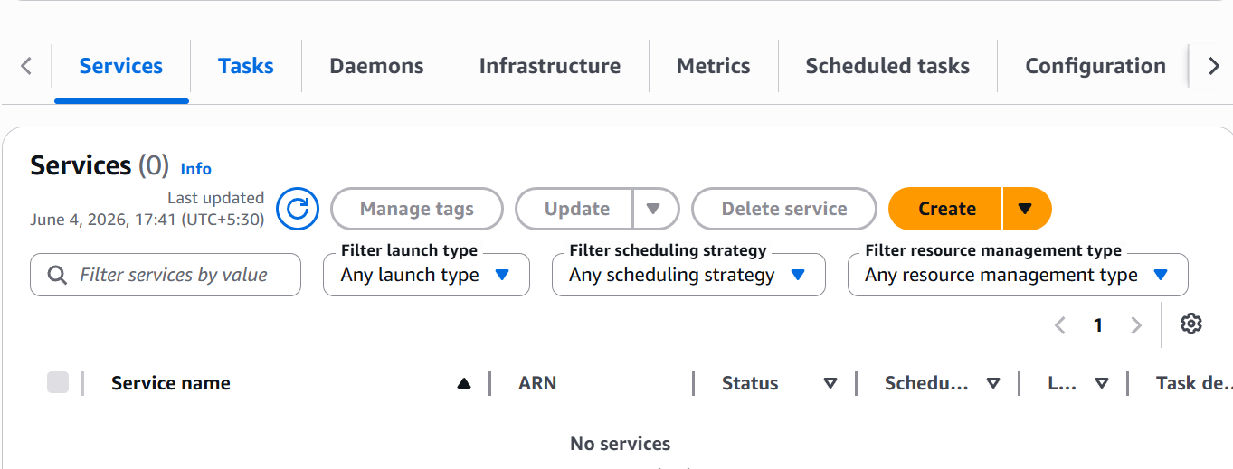
Select the task definition family and give service a name
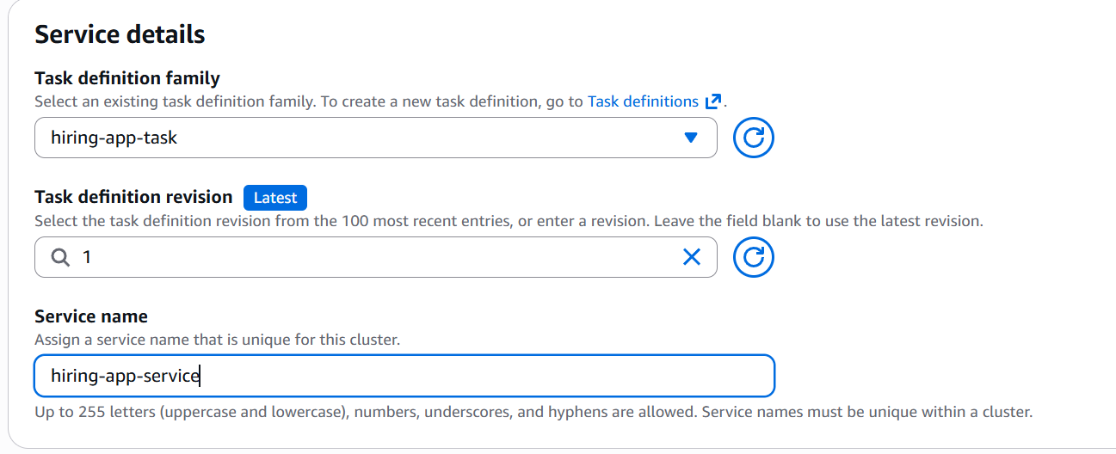

In deployment config select replica and desired tasks as 6
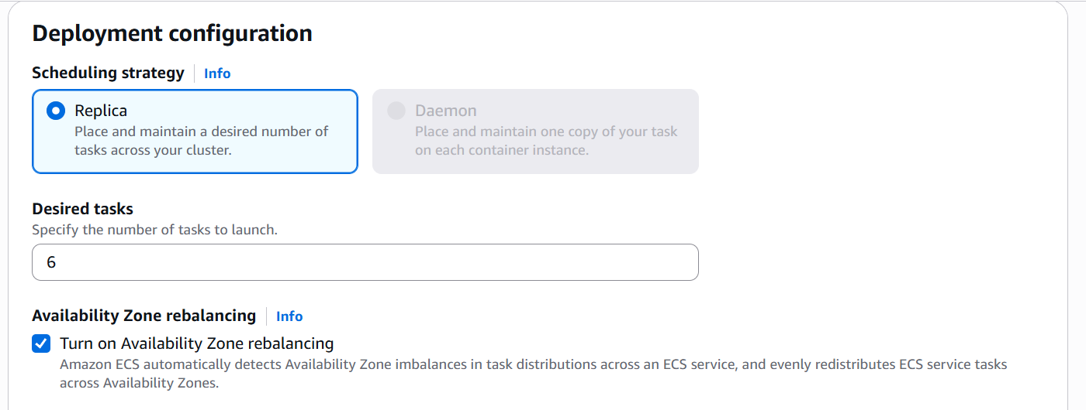

Select the load balancer
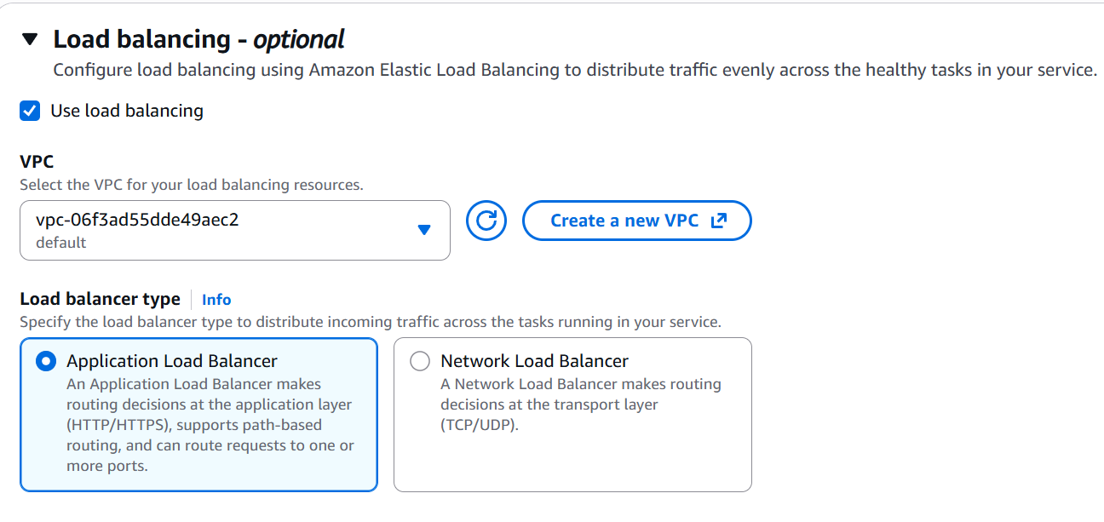
Select vpc and load balancer type
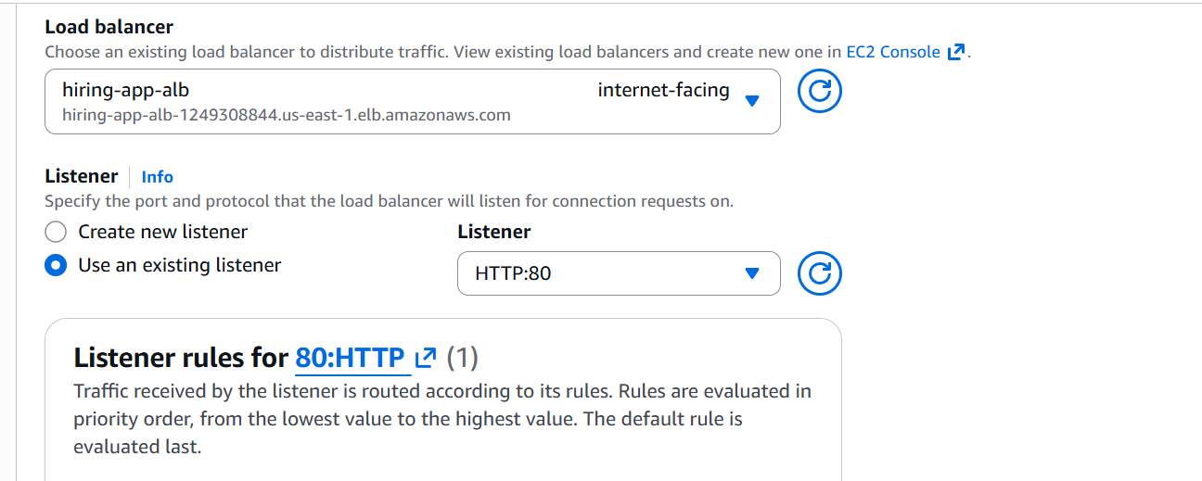

Select target group
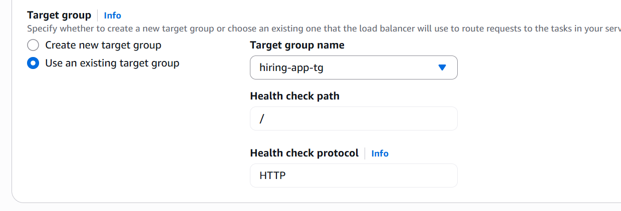
Now create the service
We can see that our tasks are running at desired state
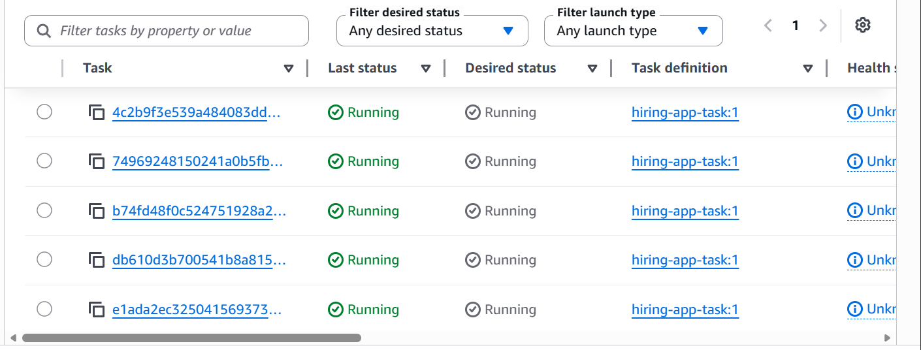
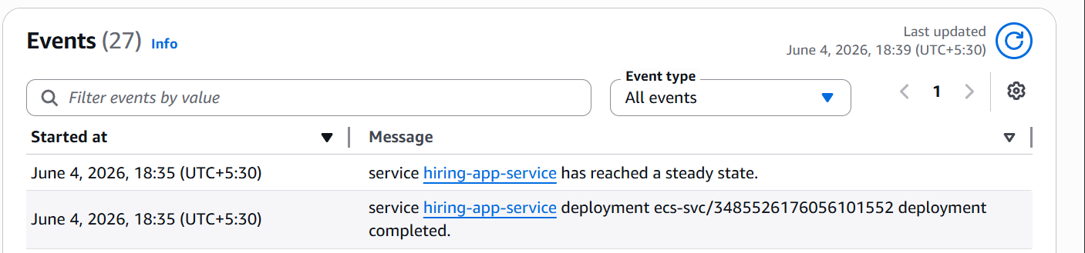
We can see that 6 tasks are running


And also we are able to access our hiring app webpage throught the loadbalancer dns

We have now created a highly available Amazon ECS cluster using EC2 launch type across multiple Availability Zones. Deployed the Docker image sabair0509/hiring-app:works behind an Application Load Balancer with dynamic port mapping enabled. Configured an ECS service with a desired count of 6 tasks and validated successful load balancing and health checks across all running tasks.

